BE 1 Exercises

Oct 30th

# Exercise 1 (Network inspect)

* Go one of the websites that you visit frequently using your browser o What is the url ?

<https://calendar.google.com/calendar/u/1/r/week>

* Open the developer tools (Inspect) and answer the following o What is the IP address of the server host [2001:4860:4802:32::78]:443  
  o How many http(s) request were made 151  
  o What are the different types returned from all of the requests 11   
  o What was the largest file returned 87.2 KB  
  o How many ms did it take? 418

# Exercise 2 (Simple Node Server)

* Go to<https://www.npmjs.com/package/http-server>
* Install the required packages
* Serve your website using the (http-server) On port 2
* Go to [http://localhost:2](http://localhost:2/)
* Open inspect > Network
* Take a screenshot and upload it

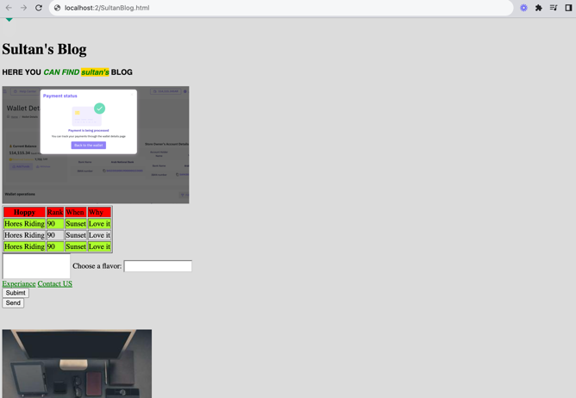

# Exercise 3 (Domain Name)

* Go to GoDaddy.com
* Find a domain name for your

